**DAILY ONLINE ACTIVITIES SUMMARY**

|  |  |  |  |  |  |  |  |
| --- | --- | --- | --- | --- | --- | --- | --- |
| **Date:** | 26/05/2020 | | | | **Name:** | AMBIKA V | |
| **Sem & Sec** | 4th SEM SECTION 'A' | | | | **USN:** | 4AL18CS005 | |
| **Online Test Summary** | | | | | | | |
| **Subject** | | Design and Analysis of Algorithms(18CS42) | | | | | |
| **Max. Marks** | | 30 | | **Score** | | 23 | |
| **Certification Course Summary** | | | | | | | |
| **Course** | Introduction to Cyber Security | | | | | | |
| **Certificate Provider** | | | GreatLearning Academy | **Duration** | | | 7 Hours |
| **Coding Challenges** | | | | | | | |
| **Problem Statement:** 1. Write a program in C to print all permutations of a given string using pointers. | | | | | | | |
| **Status:** Completed | | | | | | | |
| **Uploaded the report in Github** | | | | YES | | | |
| **If yes Repository name** | | | | https://github.com/ambika0202/lockdown-coding- | | | |
| **Uploaded the report in slack** | | | | YES | | | |

**Online Test Details:**

The online test was from module 2 which was about the Divide and Conquer, Decrease and Conquer Approach. There were 30 questions and the duration was 45 minutes. The questions were optimal and were easy. The score that I got in the test is 23/30.

**Snapshot:**

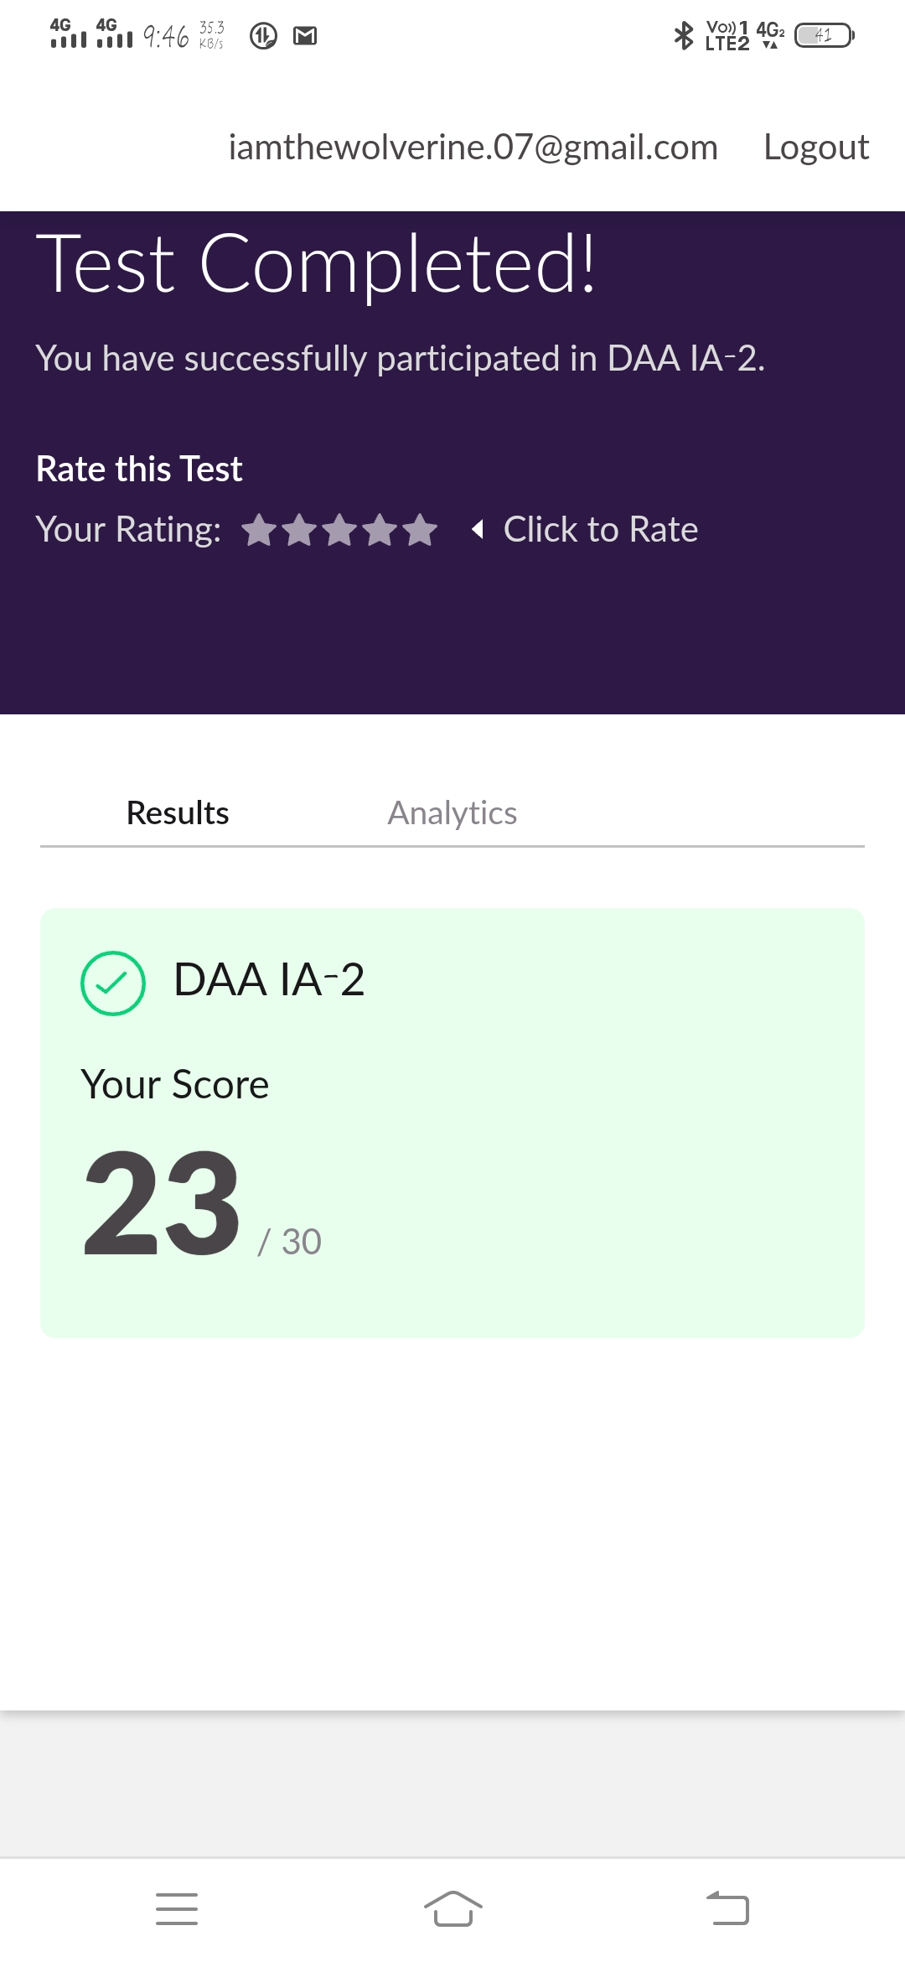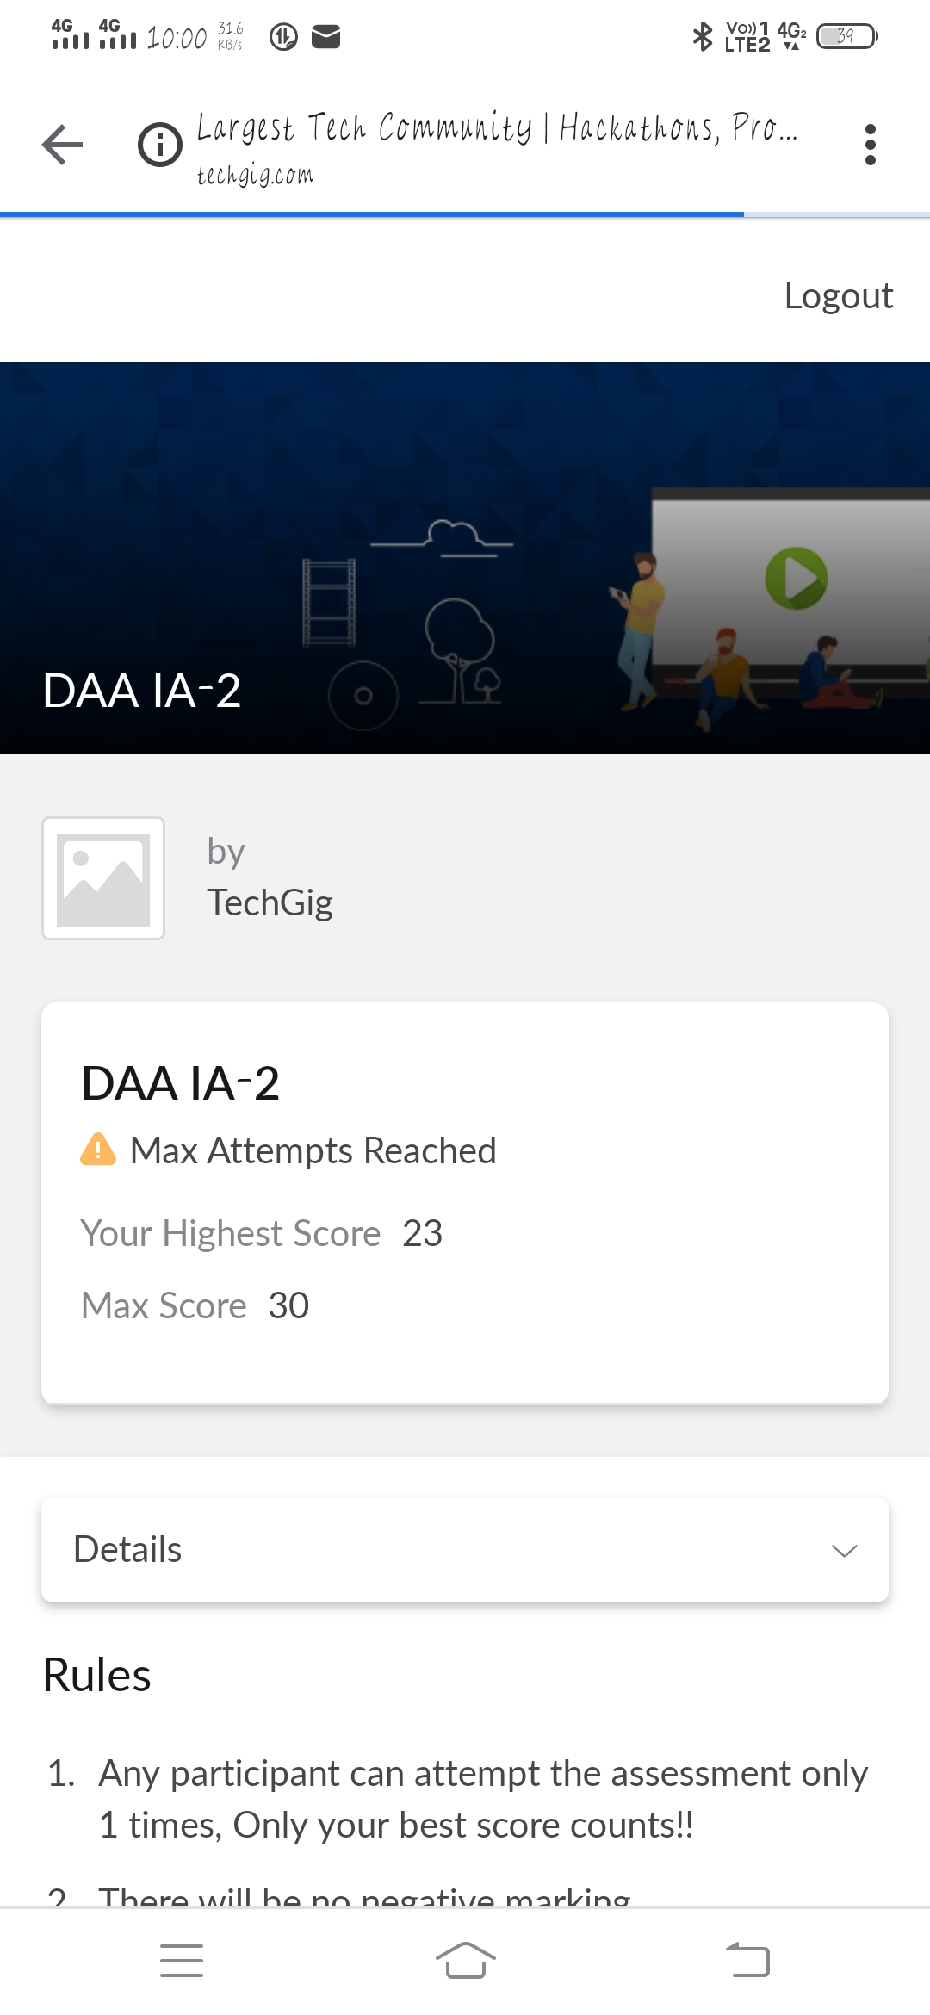

**Certification Course Details:**

**Name of the course**: Introduction to Cyber Security

**Certificate Provider**: Great Learning Academy

Today I went through the three sessions of the course that explained about Cryptograpy and secure system design.

**Snapshot:**

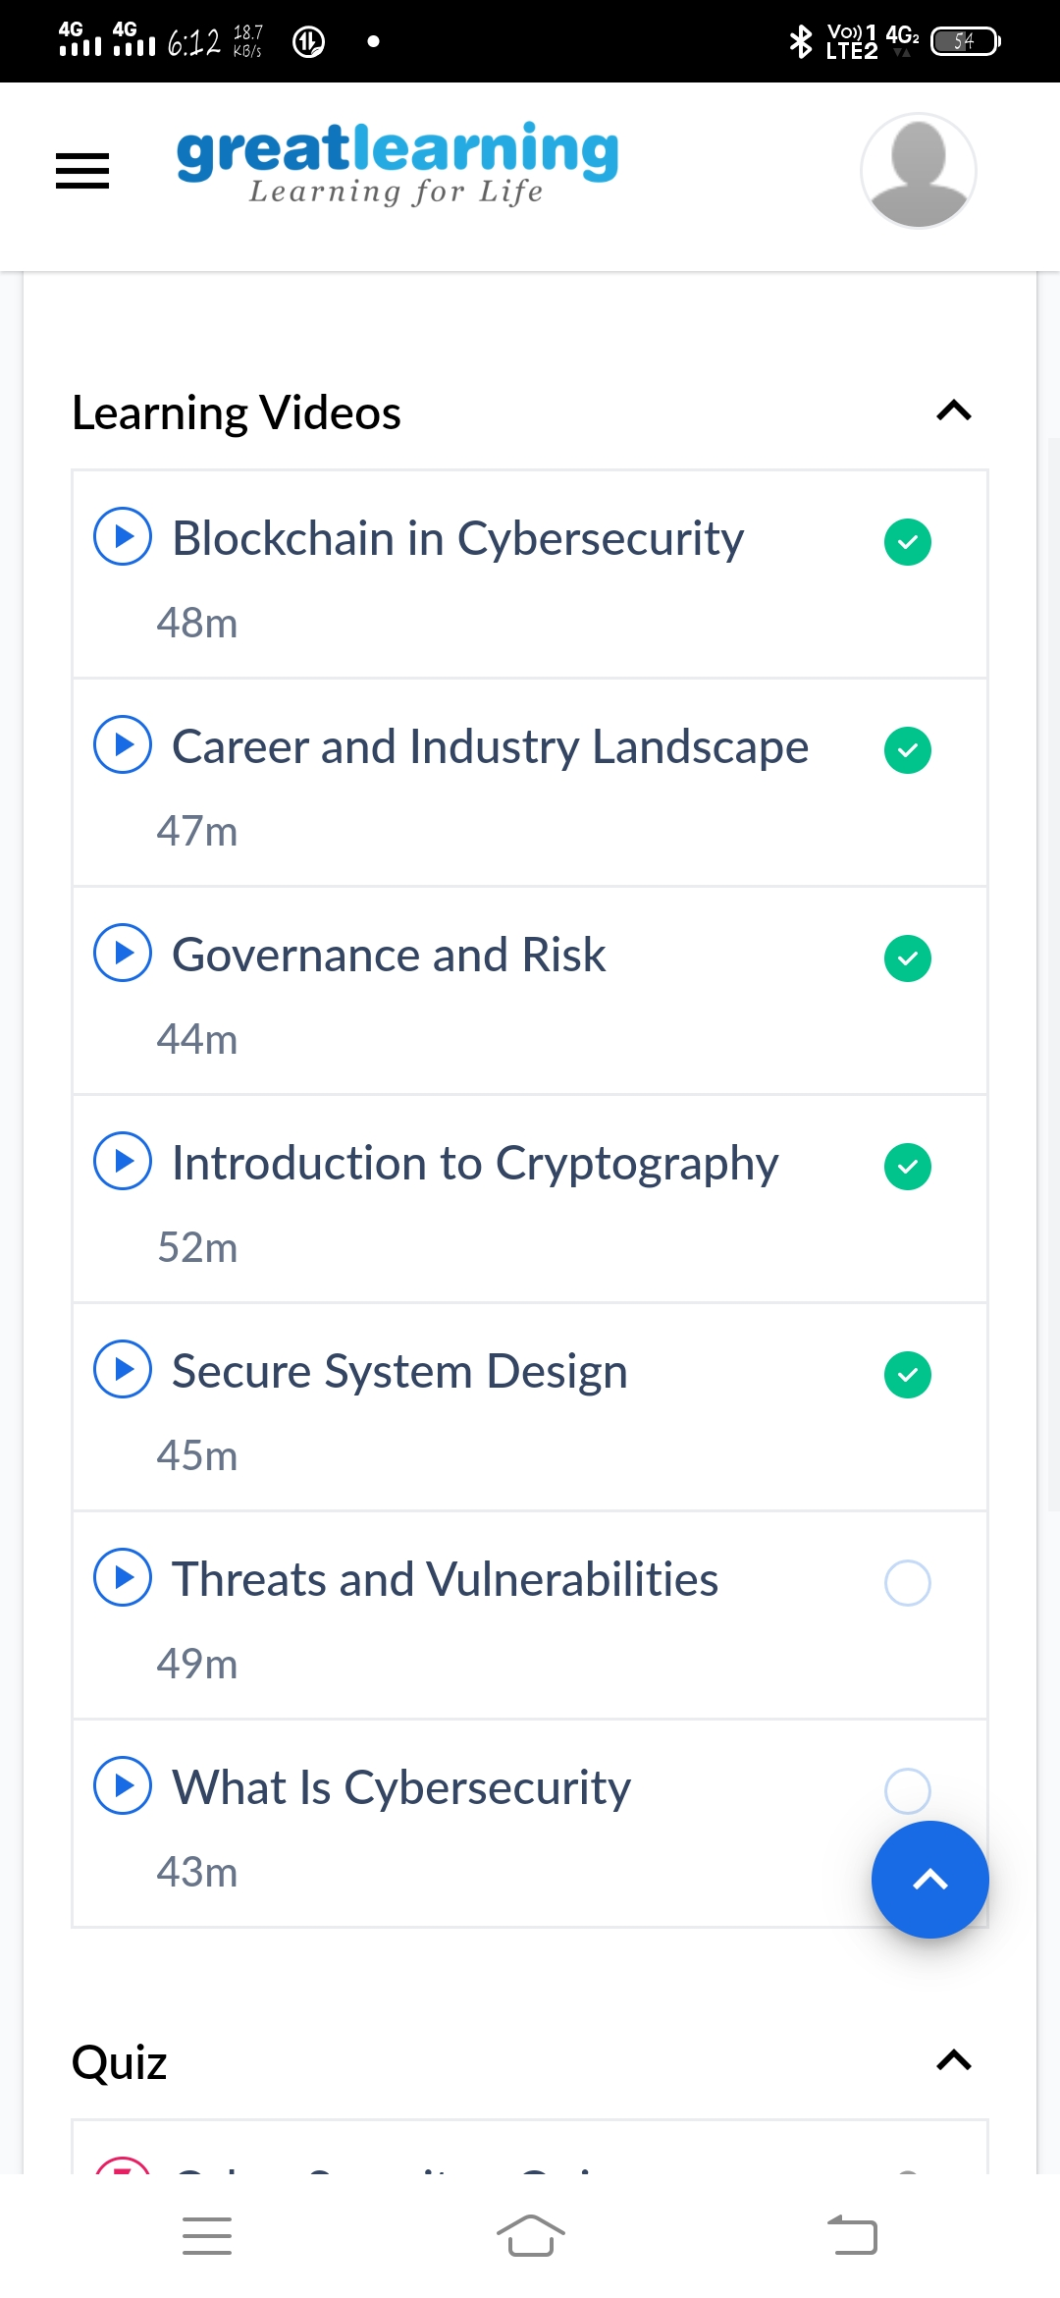

**1.Introduction to Cryptography**

Cryptography is one of the most important tools for building secure systems. Through the proper use of cryptography, one can ensure the confidentiality of data, protect data from unauthorized modification, and authenticate the source of data. Cryptography can also enable many other security goals as well.

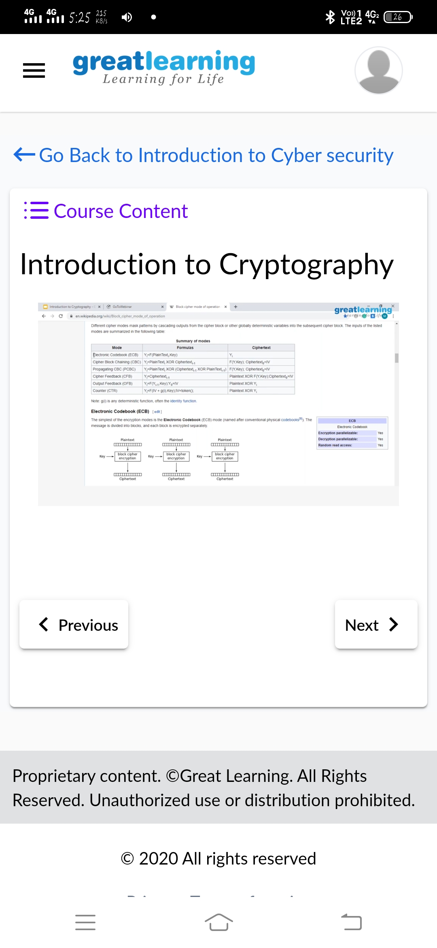

**2.Secure System Design**

Secure by design, in software engineering, means that the software has been designed from the foundation to be secure. In such approach, the alternate security tactics and patterns are first thought; among them, the best are selected and enforced by the architecture design, and then used as guiding principles for developers.



**Online Coding Details:**

Problem 1: (using C language) To print all permutations of a given string using pointers.

**Snapshot:**

